Training on Budget Execution reporting and Budget monitoring

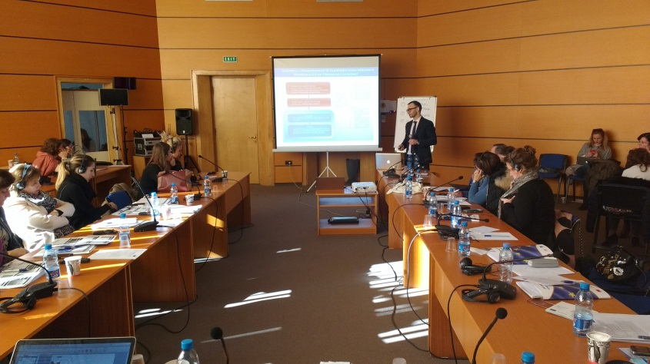
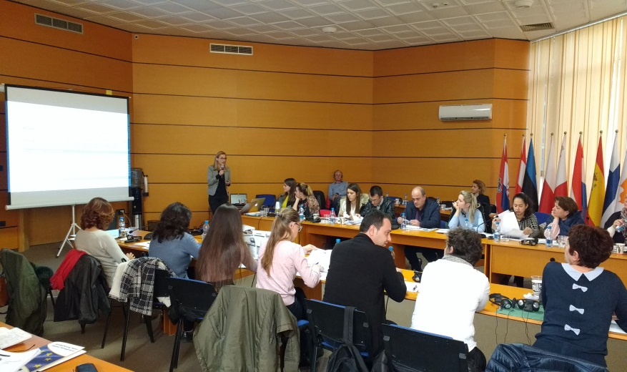
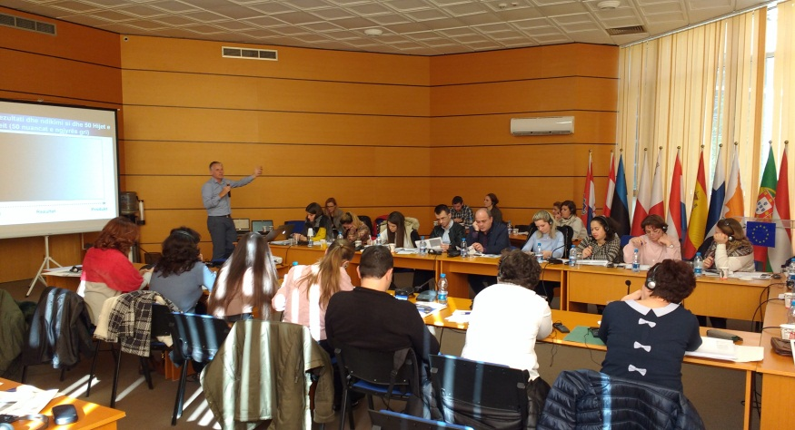
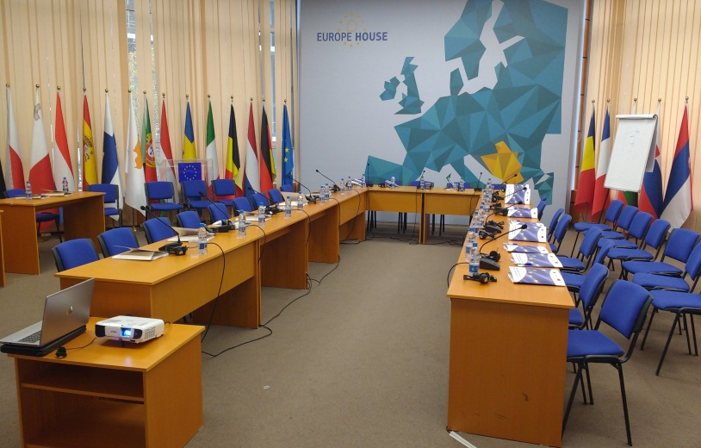
Evaluation Report
Tirana, 28 March 2019

Preface 5
1 Introduction 6
1.1 Training courses and participants 6
1.2 The programme 6
2 Course evaluation by the participants and the trainers 10
2.1 Evaluation questionnaire 10
2.2 Specific comments received during and right after the training 11
2.3 Feedback from the trainers 11
3 Course evaluation by the participants and the trainers for MoFE 12
2.1 Evaluation questionnaire 12
2.2 Specific comments received during and right after the training 13
2.3 Feedback from the trainers 13
Annex I: Training attendance sheets 12

Preface
This evaluation report presents findings and conclusions of the four-day workshop on ‘Budget Execution reporting and Budget monitoring’ conducted for staff of line ministries, Ministry of Finance and Economy and the Prime Minister Office in Albania which are involved in budget execution reporting and Budget monitoring. The four-day training course took place on 4-5 and 6-7 December 2018 in Tirana as a TA activity to ‘strengthen budget monitoring capacities at Line Ministries and Budget organisations level’.

The trainers would like to express their gratitude to the EU Delegation in Albania for making the training course possible. We would like to thank especially Mrs. Mimoza Dhëmbi (General Director of Budget and Debt Directorate and Mrs. Xhoana Agolli (Director of Budget Management Directorate) for the support to the organization of the training course and support provided to the project trainers. We would also like to express our appreciation to all the attendants of the training for their active participation.

Introduction

Training courses and participants
Objective of the MOFE training would aim at improving the MOFE’s capacity for their core functions of budget execution reporting and budget monitoring, including:
- Compiling of the Annual budget execution report;
- Scrutinizing the quality, coverage and accuracy of the Budget monitoring reports from the Line ministries;
And using the 12-month Budget monitoring reports from the Line ministries as an important input for the Annual budget execution reporting (ABER): integrating Budget monitoring with ABER.

The training course was implemented in close collaboration with MoFE which provided the training room at no costs. The training curriculum and training material have been shared with all the participants shared to promote sharing and ensure replicability of the training.

The General Directorate of Budget at MoFE sent invitations to the respective directorates which are involved in Budget Execution reporting and Budget monitoring. Beforehand, the trainers a nd the Ministry of Finance and Economy agreed an agenda prior to the training workshop. All targeted participants that attended were staff members from the general budget directorate.

The training was attended by a total of about 34 people (19 people during 11 March and 15 people during 12 March 2019) – see annex B. In general all participants attended the full training during both days since they had been sent by their managers in the training course.

The trainers comprised of three project experts, (Janis Jankovskis), (Joris Endel) and (Sabina Ymeri). The training was facilitated by Marcela Bardho.

The programme
The programme of the standard training course is outlined below.

Day 1 of the training is mostly devoted to theoretical part of the training: introduction to the updated Budget reporting and monitoring processes and overview of the best practice in the domain.

DAY 1: Overview of the updated Budget Reporting and Monitoring processes and best practices
Time | Subject, purposes | Goal / instructions | Work form
MORNING

9:00-9:15 | Arrival and welcome coffee
9:15-9:30 | Welcome, Introduction and objectives of workshop | - Acquaint participants with the aim of the workshop and to clarify general content and structure of the course | - Welcome  - Interactive presentation of trainer and participants
9:30-10:30 | Introduction to Budget execution monitoring and assessing non-financial performance (Part 1) | - What is applicable to ABER and scrutiny of Budget monitoring reports from the LMs? | - Presentation  - Q&A
10:30-10:45 | Coffee/Tea break
10:45-11:30 | Introduction to Budget execution monitoring and assessing non-financial performance (Part 2) | - What is applicable to ABER and scrutiny of Budget monitoring reports from the LMs? | - Presentation  - Q&A
11:30-12:00 | Overview of the amendments to the Budget Monitoring Instructions and processes | - Present the revised Budget Monitoring Instructions and the updated templates (forms) | - Presentation  - Q&A
12:00-12:30 | Overview of the Budget Monitoring Checklist to achieve improvements in the quality of the budget monitoring | - Discuss the Monitoring checklist prepared to assist the LMs and MOFE in Budget monitoring processes | - Presentation  - Q&A
12:30-13:30 | Lunch (buffet)
AFTERNOON

13:30-14:30 | Group work:  Part 1. Using the latest 8-month actual monitoring reports and outturn, prepare the main conclusions (including the follow up activities) of the monitoring report for the selected budget programme | - Select the largest Budget programme (in terms of funding as % from the total Budget) of the relevant ministry  - Exercise shall look at both financial and non-financial performance and assess the linkages between the two dimensions | - Group exercises
14:45-15:30 | Budget reporting, monitoring and programme evaluation practices in the OECD countries | - International practice and standards in Budget execution reporting and monitoring | - Presentation  - Q&A
15:30 | Wrap up of DAY 1 | - Summarizing DAY 1

Day 2 of the training is mostly devoted to practical group exercises with an aim to strengthen the quality of the Annual budget execution report and efficiency of scrutinizing Budget monitoring reports from the Line ministries, with an emphasis on non-financial performance.

DAY 2: Practical group exercises to strengthen capacity to scrutinize non-financial performance and Budget monitoring reports
Time | Subject, purposes | Goal/Benefit | Work form
MORNING

9:00-9:15 | Arrival and welcome coffee
9:15-10:30 | Overview of the main Evaluation concepts (model 3E’s) and using them in budget monitoring and assessment of the budget performance | - Present the existing gaps of the ABER and recommendations to address the gaps | - Presentation  - Q&A  - Brief exercise
10:30-10:45 | Coffee/Tea break
10:45-11:30 | Streamline of the Annual Budget execution reporting (ABER) | Present the existing gaps of the ABER and recommendations to address the gaps | - Presentation  Q&A
11:30-12:30 | Group work:  Part 2. Present the outcome of the Part 1 of the Group exercise
12:30-13:30 | Lunch (buffet)
AFTERNOON

13:30-14:30 | Group work:  Part 3. Perform assessment of quality of the monitoring conclusions from Part 2 | The MOFE has to prepare the formal review on each Budget monitoring report from all ministries  - Each group is exchanging its monitoring conclusions from Part 1 with another group and preparing the “MOFE review of the Monitoring report” (including conclusions on budget execution performance, gaps/ bottlenecks, additional information requirements, and the proposed follow up) | - Presentation by each group
14:30-15:20 | Discuss the proposed improvements and better integration of the budget reporting, monitoring and MTBP processes | - Understand how budget reporting, monitoring and MTBP (budget preparation) processes are interlinked  - Discuss required changes in the business processes | - Q&A
15:20 | Wrap up of DAY 2 | - Summarizing DAY 2

In the preparatory phase the training materials were developed. All topics were addressed during the training.

The course delivery provided for a mix of learning approaches, with a strong focus on exercises and practical cases. The courses were interactive and consisted of PowerPoint presentations with ample room for questions and discussion, and exercises in sub-groups equipped with laptops and hand outs of the budget monitoring reports of specific cases chosen.

During the training a lively, open and revealing discussion took place on the new budget monitoring template introduced by the TA project and especially during the exercises (see box below).

Box 1: Challenges with budget monitoring tamplate/ comments/ questions raised
- Please add comments;
- Please add comments;

The participants received electronic copies (USB) of the PowerPoint presentations and exercises as well as all the Budget Monitoring Reports of 2018.

Course evaluation by the participants and the trainers

Evaluation questionnaire
At the end of each standard training, the trainers distributed a hard copy evaluation form. Overall the training was highly evaluated. Most variation concerned the issue on the level of difficulty & understanding. The majority (80%) felt it was ‘just right’ and ‘somewhat hard’.

Below, a consolidated overview of the average scoring for each of the multiple choice questions is presented.

Table 2: Training evaluation
 | Excellent | Good | Satisfactory | Unsatisfactory | Poor | Total | % Excellent/Good
The programme | 24 | 22 | 1 |  |  | 47 | 98%
Quality of Presentation | 30 | 16 | 1 |  |  | 47 | 98%
Quality of Instruction | 27 | 18 | 2 |  |  | 47 | 96%
Interactivity of participants | 8 | 28 | 10 | 1 |  | 47 | 77%
Fullfillment of your Expectations | 10 | 34 | 3 |  |  | 47 | 94%
 | Much too hard | Somewhat hard | Just right | Somewhat easy | Too Easy |  | % Just Right/Somewhat easy
Level of difficulty & understanding |  | 4 | 33 | 5 | 4 | 46 | 80%
 | Excellent | Good | Satisfactory | Unsatisfactory | Poor
Overall training | 11 | 34 |  |  |  | 45 | 100%
Suitability of the Venue | 9 | 31 | 7 |  |  | 47 | 85%
Hospitality | 24 | 21 | 2 |  |  | 47 | 96%
No. of completed questionnaires: 47

Which training Session did you find most useful? State a session from the workshop programme?
- Overview of the best OECD practice and approaches for assessing non-financial performance
- Monitoring and Evaluation.
- Streamline of the Annual Budget execution reporting (ABER).
- Amendments to the Budget Monitoring Instructions and processes.
- Preparation of the monitoring report.
- Integration of financial and non-financial information.
- Monitoring Templates (forms) with the basic data from the approved 2018 budget documents

Which training Session did you find least useful? State a session from the workshop programme?
- Model of 3E.
- Preparation of the Monitoring report.

In what other areas related to MTBP would you like training?
- Budget Programming.
- Monitoring key performance indicators.
- Budgeting and Budget Monitoring practical exercises.
- The Model of 3E.
- Budget planning refered to AFMIS.
- The new AFMIS.
- Planning and Programing.
- Implementation of the annual budget.
- Activities and outcome identification from the LMs.
- Non-financial performance (practical exercises).
- Budget monitoring (non-financial).
- Audit program with EU standards.

On scale 1 to 5, would you recommend this training to your peers? 1 = Very Much; 5 = Not at all
 | 1 = Very much | 2 | 3 | 4 | 5 = Not at all | Total | % 1-2
On scale 1 to 5, would you recommend this training to your peers? 1 = Very Much; 5 = Not at all | 19 | 20 | 3 | 2 | 2 | 46* | 85%
*1 not filled in

Specific comments received during and right after the training
The feedback received during and after the training is largely in line with the scoring above. Participants were positive about the training. Most comments referred to the duration or timing of the training or the need to have follow-up training courses per line ministry.

Feedback from the trainers
The trainers have enjoyed providing the training to this group of participants. The size was of the group varied. In the last two standard training courses the demand exceeded the available places. At one moment more than 40 people participated in the last two standard training courses. The training room of Europe House was able to add tables and chairs and accommodate all participants.

Most participants were actively involved, asking questions, and applying the learning during the exercises.

While the invitations were sent by the Ministry of Finance and Economy to targeted officials, and the majority of them were key technical staff of the respective line ministries. Only on few cases subordinate staff was sent.

An important aspect of the training is the interaction among participants but also the interaction between the presenters and the audience. The audience interaction was good throughout the training. The participants were not afraid to pose questions during the presentations. The discussion new budget monitoring template was very open and revealing. While the training material was extensive, none of the sessions had to be rushed because of lack of time.

Course evaluation by the participants and the trainers for MoFE
This section of the report presents findings and conclusions of the two-day workshop on ‘Budget Execution reporting and Budget monitoring’ conducted for staff of the Ministry of Finance and Economy (MoFE) only. The two-day training course took place on 11-12 March 2019 in Tirana as a TA activity to ‘strengthen budget monitoring capacities at MoFE.

The trainers would like to express their gratitude to the MOFE in Albania for making the training course possible. We would like to thank especially Mrs. Mimoza Dhëmbi (General Director of Budget and Debt Directorate and Mrs. Xhoana Agolli (Director of Budget Management Directorate) for the support to the organization of the training course and support provided to the project trainers. We would also like to express our appreciation to all the attendants of the training for their active participation.

Evaluation questionnaire

Specific comments received during and right after the training

Feedback from the trainers

Annex I: Training attendance sheets
DAY 1
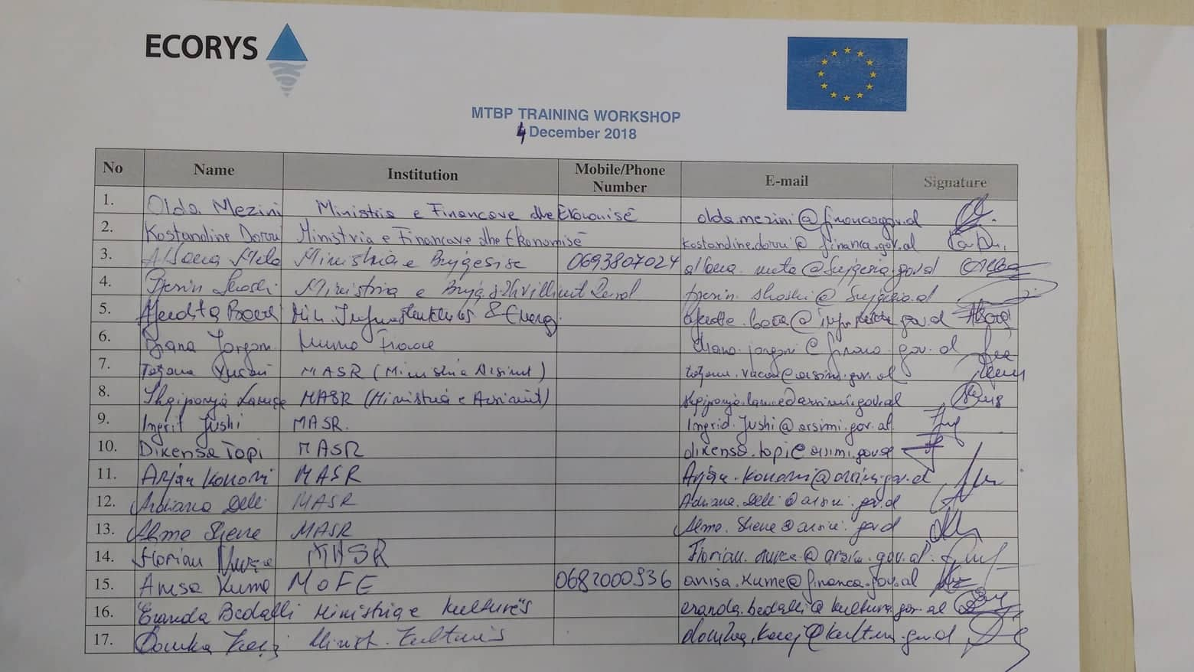
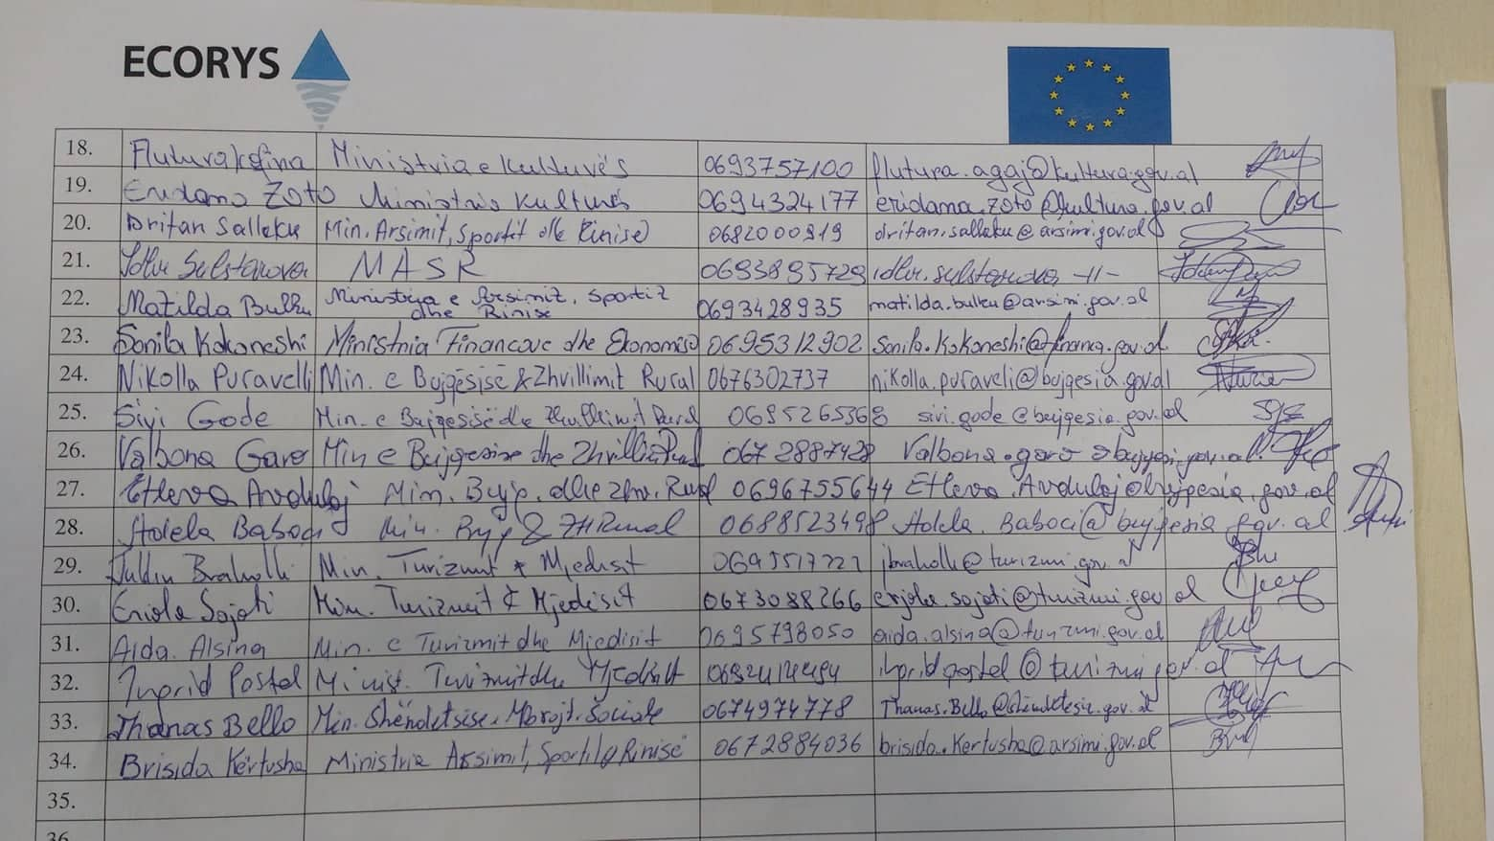

DAY 2

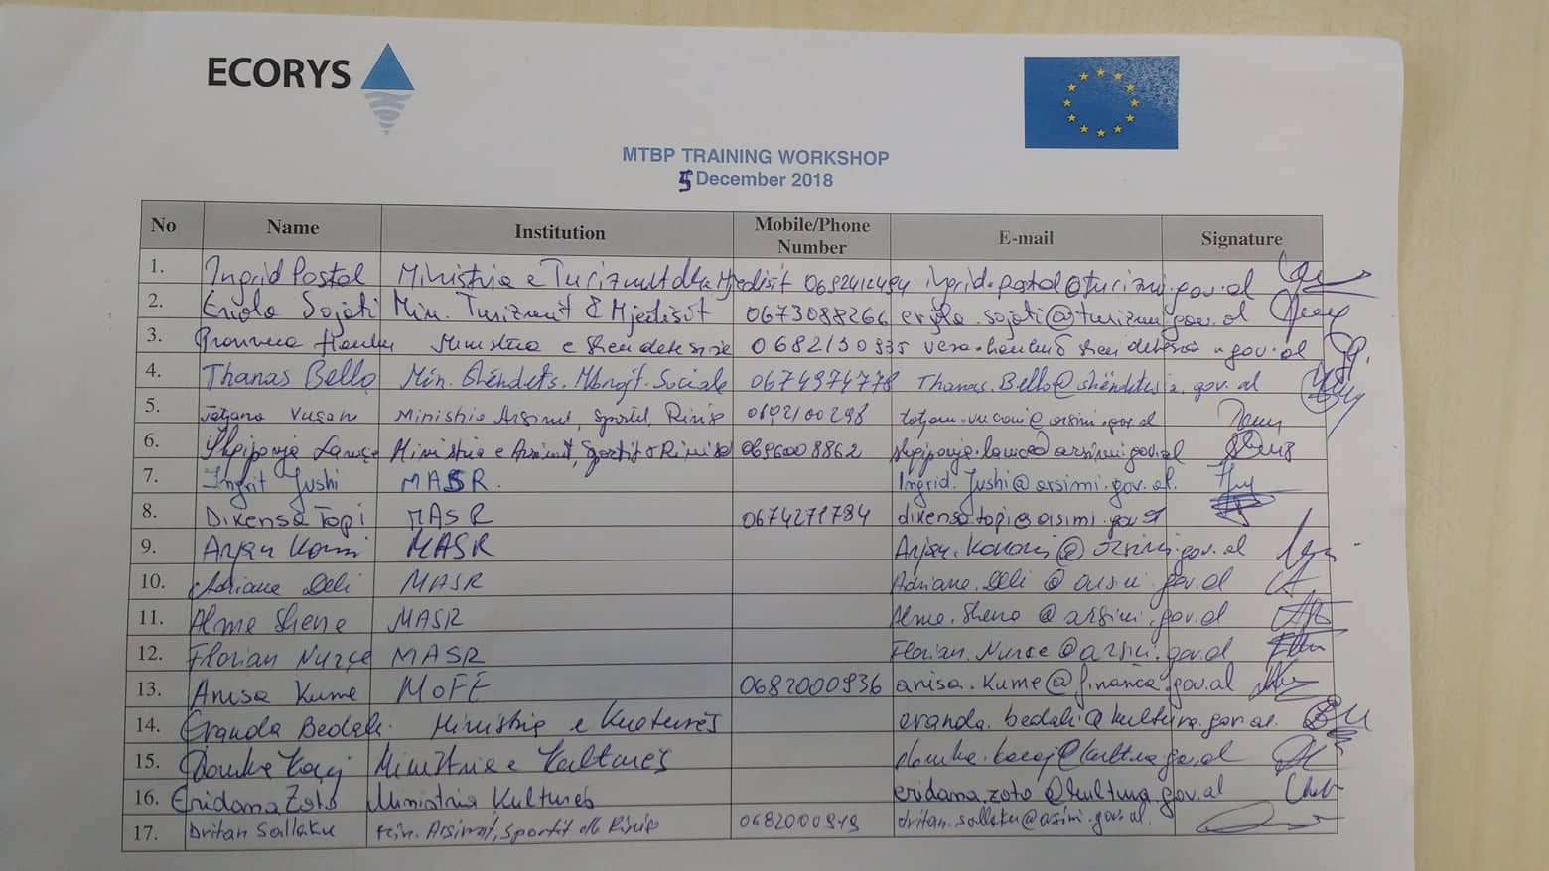
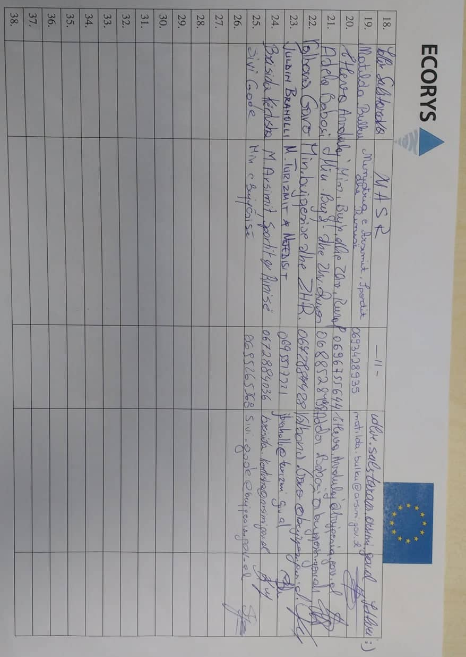

DAY 3
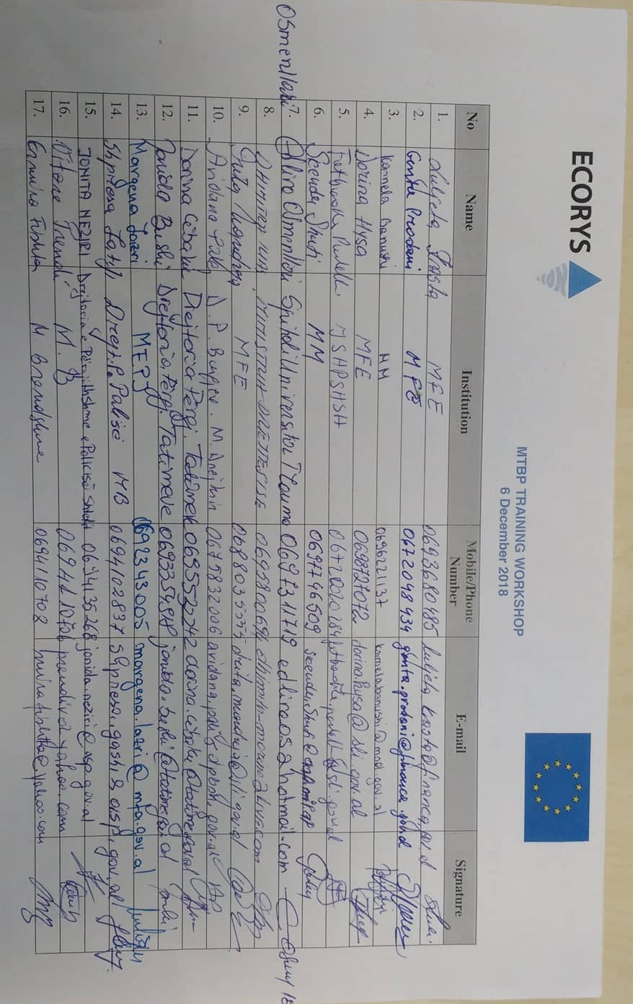

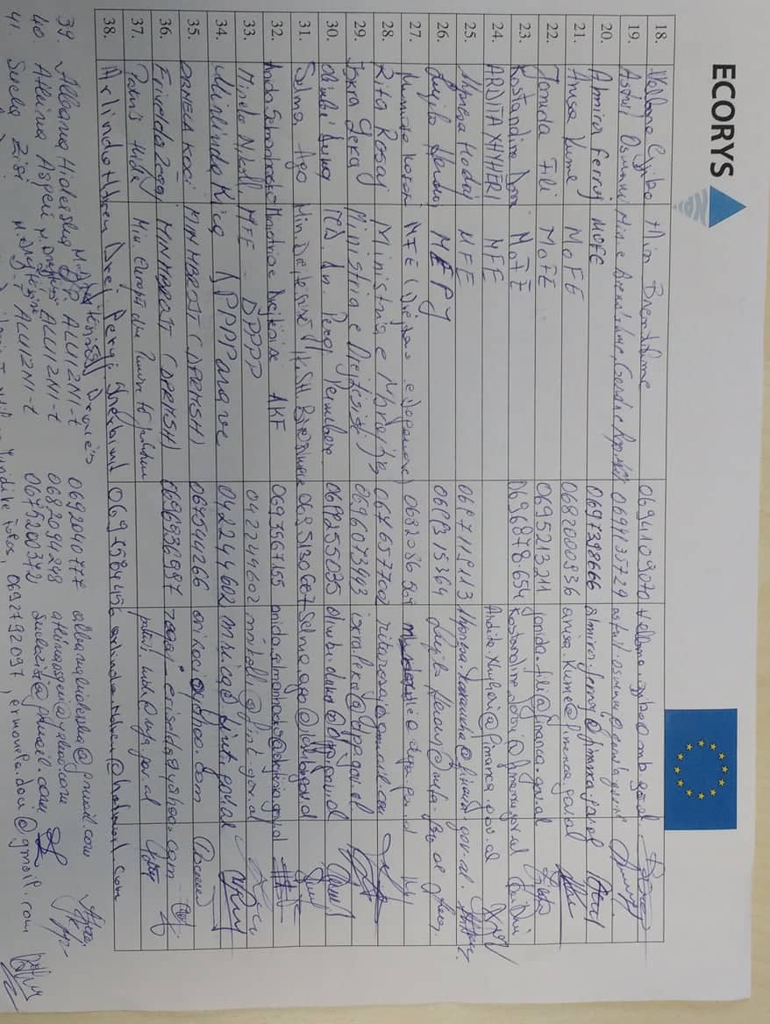

DAY 4

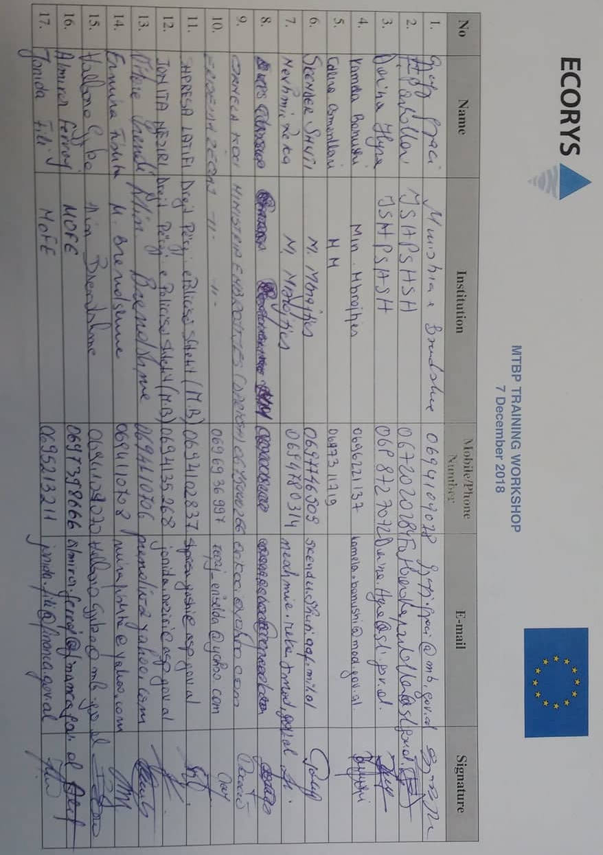
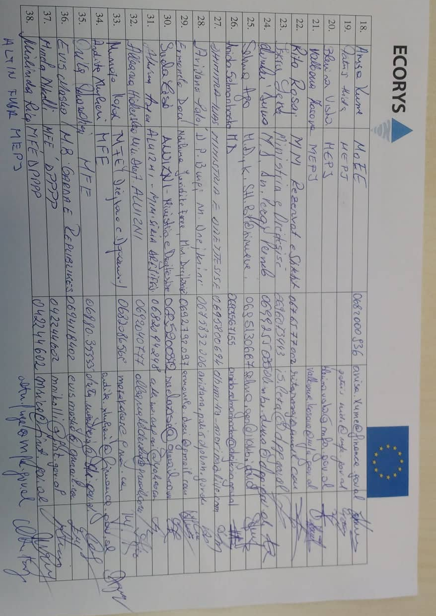

P.O. Box 4175
3006 AD Rotterdam
The Netherlands

Watermanweg 44
3067 GG Rotterdam
The Netherlands

T +31 (0)10 453 88 00
F +31 (0)10 453 07 68
E netherlands@ecorys.com

W www.ecorys.nl

